-Installing Vpython on your computer:
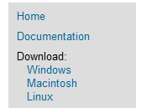
- Navigate to http://vpython.org/
- Select your operating system
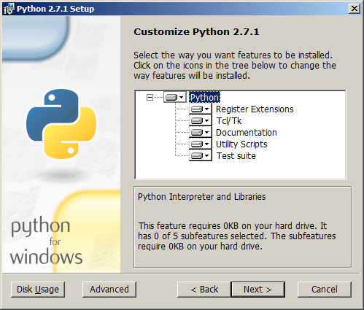
- Download and install Python-2.7.1

- Download and install Vpython-xxx-Py2.7-5.72
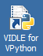
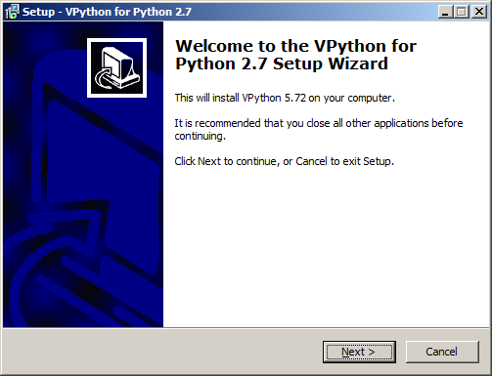
- Double click on the VIDLE for VPython Icon to start the development environment
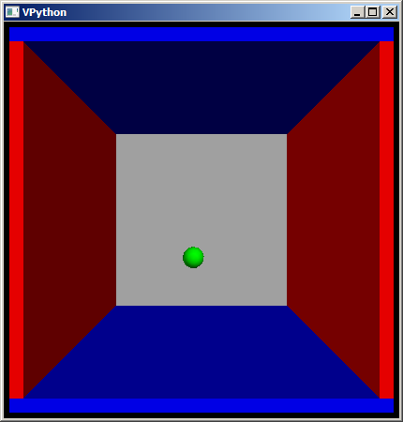
- Open an example program -- for example, bounce2.py.
- Press F5 to run (or use the Run menu).

